**DOCUMENTATION FOR SCENARIO-2:**

* **What is Scenario-2?**
* **Alice, are old user, has come again into the WINGS WORKFLOW SYSTEM.**
* **She wanted to create a new workflow this time but she wants to use another Sorting_Algorithm this time known as BubbleSort.**
* **She some how figured out that the BubbleSort Algorithm requires one additional parameter called number_input besides the input_file.**
* **She goes in the WINGS WORKFLOW SYSTEM and changes her abstract component SORT and adds an extra parameter for the abstract component.**
* **She creates a new workflow this time with the abstract component SORT.**

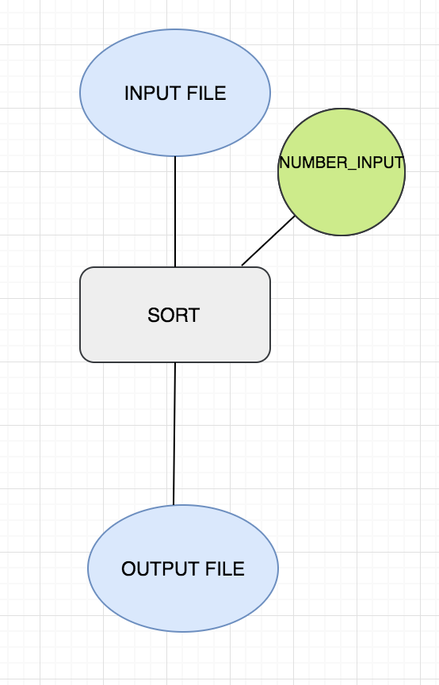

* **She now decides to execute that workflow using her new algorithm BubbleSort.**

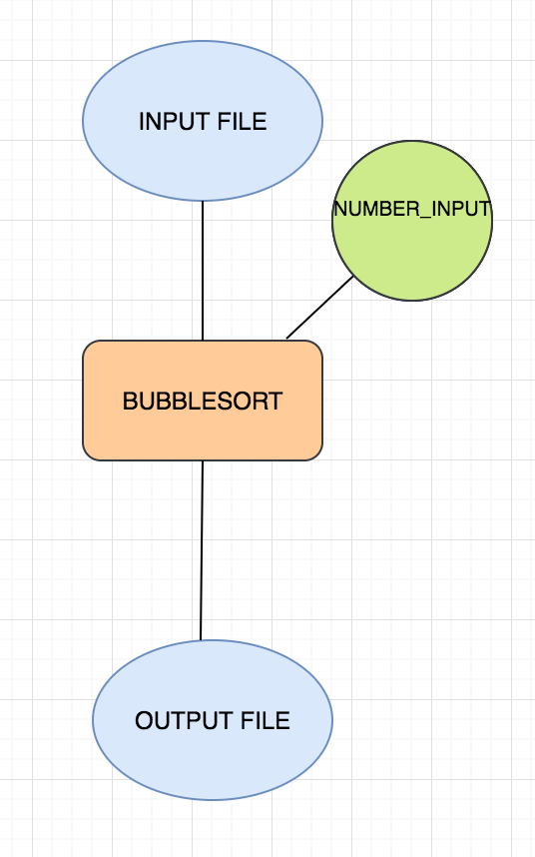

* **She has created this very well and everything works well.**
* **The PROBLEM comes in now……..**
* **Well, the component catalog currently has Mergesort, QuickSort and the newly added BubbleSort under the same abstract component SORT which is WRONG.**
* **SOLUTION:**
* **We are creating a new TAXONOMY HIERARCHY MODEL (THM) for exporting these changes that will help maintaining a good consistency of components and versioning.**
* **Now, when Alice created a change in the abstract SORT Component, we create a new export in the THM.**
* **We have already exported SORT_V1 and QuickSort and MergeSort under it along with their canonical instances.**

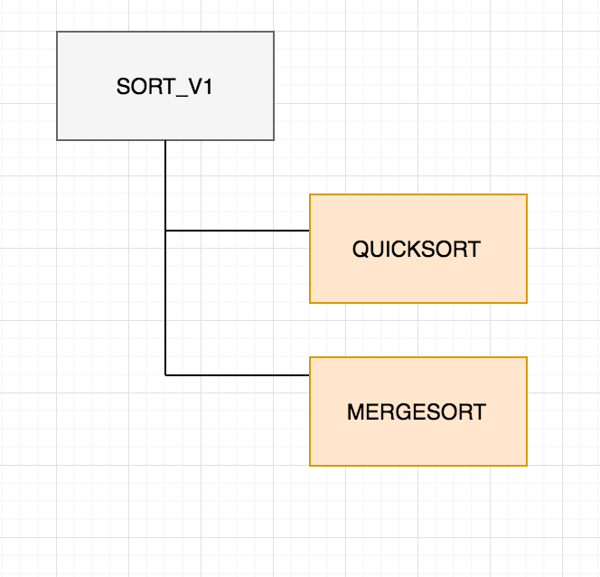

* **We will now export SORT_V2 with BubbleSort under it along with the canonical instance.**

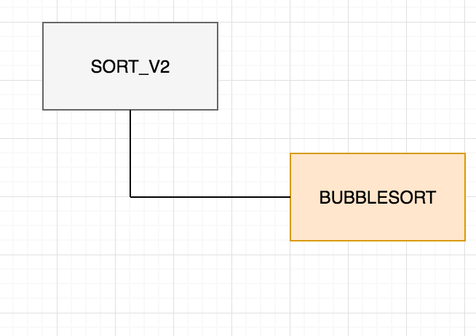

* **Further we connect the canonical instances of SORT_V2 to SORT_V1 and say that it is a prov:is revision of SORT_V1.**

